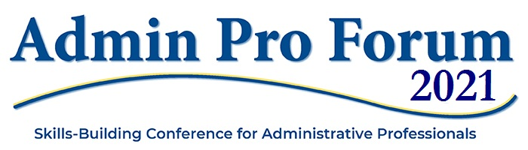
Live and virtual from the comfort of your home or office!

Dear ____________:

A recent survey run by OfficeTeam asked more than 600 senior managers in the U.S. and Canada how valuable their administrative assistants are to them. All 600+ said their assistants are important to their success.

I know that executives like you want skilled assistants. You also want motivated assistants. That’s why I think the Admin Pro Forum will benefit both of us.

The Forum, now in its fifth year, takes place May 20-21 right on my desktop—no travel necessary. It features a number of renowned speakers who will discuss, via video, topics that touch on every facet of my job. I’ll be able to apply dozens of new skills, procedures and ideas to the office. For example:

- Time management and organization: I’ll learn better ways to handle a heavy load without getting overwhelmed (or buried)
- Tech skills: I’ll develop and increase my skills in collaboration tools, remote work security, and developing technologies
- Project management: I’ll learn how to oversee and orchestrate projects the way experts do
- Manager/employee partnerships: I’ll discover ways to build a better relationship with you so both of our jobs go more smoothly

I know that I’ll sign off from this event inspired, excited and even more motivated than I already am.

I’ll also be given comprehensive course materials that I can use to continue improving my skills after the Forum. And we’ll receive a free six-month trial to Administrative Professional Today, as well as access to its members-only website.

The Admin Pro Forum is presented by Business Management Daily, which has been providing sound business news and advice since 1937. They host dozens of webinars every month, and have expanded to live events with the goal of helping attendees develop and expand their skills.

The Forum is like attending a month’s worth of webinars all in just two days!

One other benefit: The Admin Pro Forum is about half the price of other admin conferences. We still have time to take advantage of their Early-Bird Discount – but we need to act now to get the maximum savings. Please get back to me as soon as you can so I can register for this exciting event.

Sincerely,

____________________

P.S. Visit www.AdminProForum.com to see the entire program, and to read and view what other admins have said about the conference.

P.P.S. The Forum offers a full, 100% refund if I’m not completely satisfied with the event. We’ll even get to keep the course materials and free bonus gifts. I can’t think of a better deal than this.

